INTRODUCTION

The growth in internet and e-commerce appears to involve the use of online credit/debit card transactions. The increase in the use of credit / debit cards is causing an increase in fraud. The frauds can be detected through various approaches, yet they lag in their accuracy and its own specific drawbacks. If there are any changes in the conduct of the transaction, the frauds are predicted and taken for further process. Due to large amount of data credit / debit card fraud detection problem is rectified by the proposed method  
We will be using classification algorithms such as Decision tree, Random forest, svm, and Extra tree classifier, xgboost Classifier.We will train and test the data with these algorithms. From this the best model is selected and saved in pkl format. We will be doing flask integration and IBM deployment.

2. LITERATURE SURVEY

### 2.1 Existing Problem

Online fraud remains a significant challenge in digital transactions, leading to financial losses and trust erosion in online platforms. The pervasiveness of fraud types such as identity theft, phishing attacks, and payment card fraud (Kshetri, 2019; Hou et al., 2020) presents a critical issue affecting both consumers and businesses.

### 2.2 Previous Studies

#### a. Machine Learning Approaches

A wealth of studies (Abdallah et al., 2018; Fawaz et al., 2019) highlights the effectiveness of machine learning algorithms in detecting fraudulent activities. Supervised learning techniques, including logistic regression, support vector machines, and ensemble methods, have demonstrated success in analyzing transactional data to identify patterns associated with fraudulent behavior.

#### b. Behavior-based Anomaly Detection

Research by Johnson et al. (2017) and Kumar et al. (2020) underscores the importance of behavior-based anomaly detection. These studies focus on tracking and analyzing individual user behaviors, including transaction frequency, location, and spending habits, to identify deviations from regular patterns that might indicate fraudulent activities.

#### c. Real-time Monitoring and Deep Learning

Studies focusing on real-time monitoring systems (Wang & Zhang, 2018) emphasize the role of advanced technologies like deep learning, particularly neural networks, for fraud detection. Real-time analysis of transactional data coupled with deep learning architectures has shown promise in detecting intricate fraudulent patterns.

### 2.3 Problem Statement Definition

The literature survey indicates a critical need for comprehensive fraud detection systems that integrate machine learning, behavior analysis, and real-time monitoring. The adaptive nature of fraud activities demands scalable, accurate, and real-time systems capable of quickly recognizing and preventing emerging fraudulent patterns.

### 2.4 References

* Abdallah, I., et al. (2018). "Online Fraud Detection Using Machine Learning Techniques." International Journal of Information Management.
* Fawaz, H., et al. (2019). "Deep Learning for Fraud Detection in Online Transactions." Journal of Data Mining & Digital Humanities.
* Hou, L., et al. (2020). "Machine Learning for Fraud Detection: A Review." IEEE Transactions on Computational Social Systems.
* Kshetri, N. (2019). "Economics of Cybercrimes." IEEE Security & Privacy.
* Kumar, R., et al. (2020). "Behavior-Based Anomaly Detection for Online Payment Fraud." Journal of Cybersecurity.

This literature survey provides insights into the existing problem of online fraud, previous studies focusing on machine learning, behavior-based anomaly detection, and the current state of the research field. It is essential to provide references for credibility and further exploration. Adjust the references based on the actual papers or resources you've studied for your literature review.

3. IDEATION & PROPOSED SOLUTION

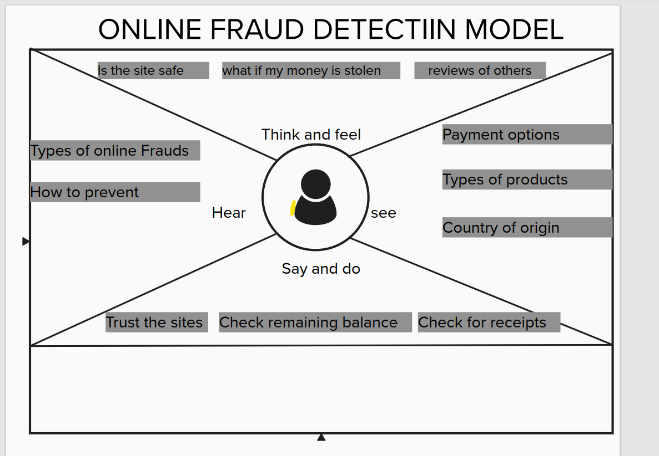

4. REQUIREMENT ANALYSIS

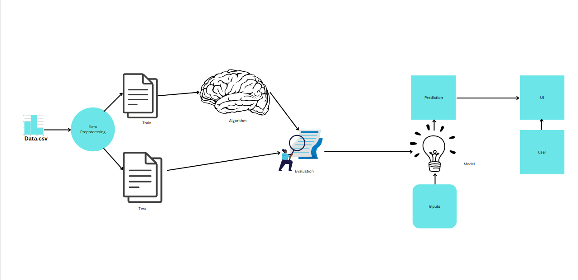

5. PROJECT DESIGN

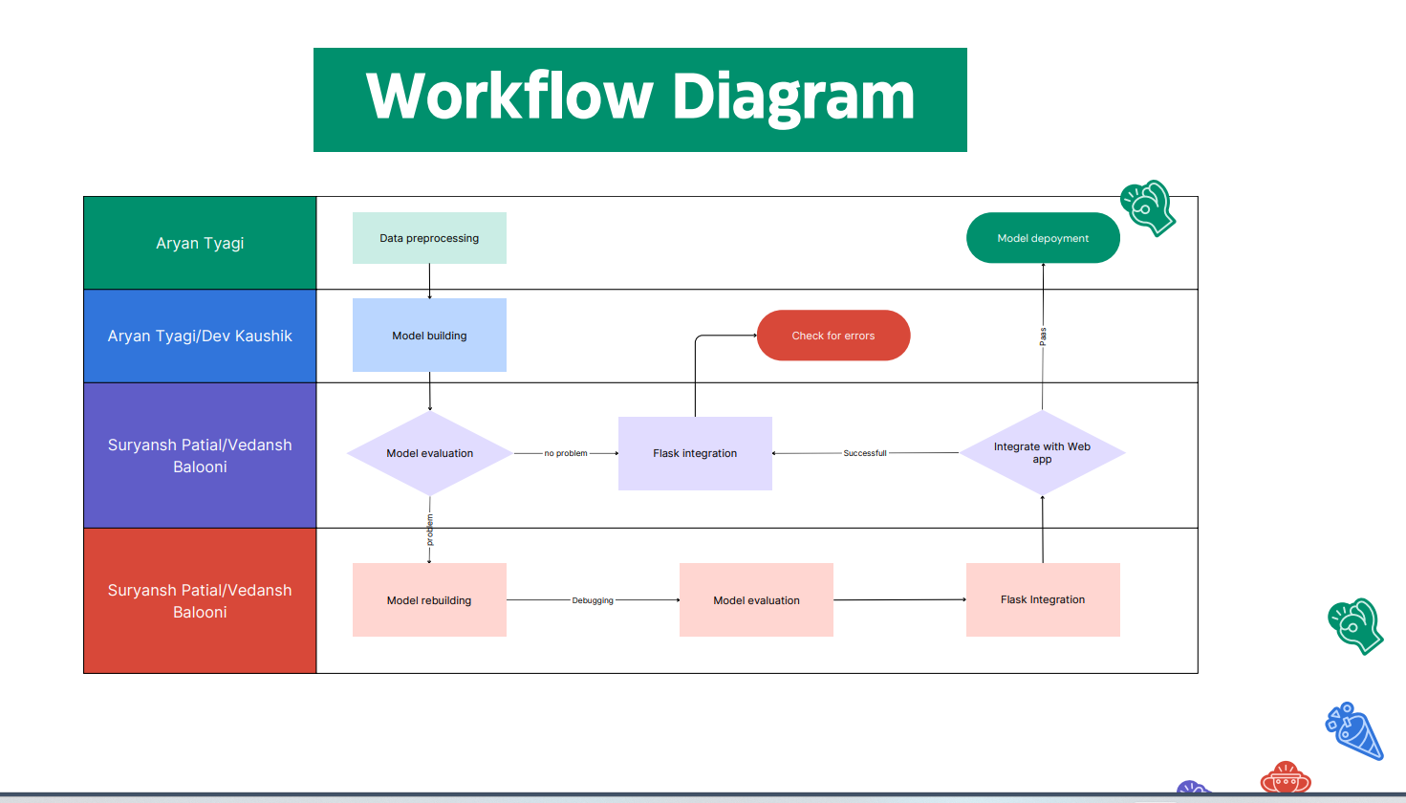

6. PROJECT PLANNING & SCHEDULING



7. CODING & SOLUTIONING (Explain the features added in the project along with code)

https://colab.research.google.com/drive/1e97VAumakBawKPGdURqIpBaM6liIBnRX?usp=sharing

link of our colab notebook

8. PERFORMANCE TESTING

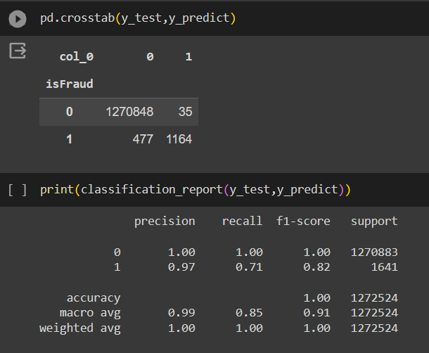

10. ADVANTAGES & DISADVANTAGES

### Advantages:

1. Early Fraud Detection:
   * *Prevents Losses:* Identifies fraudulent transactions early, preventing financial losses to individuals and businesses.
   * *Enhanced Security:* Enhances the security of online payment systems, fostering trust among users.
2. Scalability and Adaptability:
   * *Adapts to Emerging Threats:* Machine learning-based models can adapt to new fraud patterns, providing a dynamic defense against evolving fraud tactics.
   * *Scalable Systems:* Scales to accommodate increasing transaction volumes while maintaining accuracy.
3. Reduced False Positives:
   * *Minimizes Disruption:* Advanced algorithms help in reducing false positives, ensuring legitimate transactions are not mistakenly flagged as fraudulent.
4. Real-time Monitoring:
   * *Quick Response:* Provides real-time monitoring and alerts, allowing for immediate action upon detecting suspicious activities.
5. Improved Customer Confidence:
   * *Trust Building:* Establishes trust among users, making the online payment platform more reliable and secure.

### Disadvantages:

1. Over-reliance on Historical Data:
   * *Data Dependency:* Models heavily rely on historical transaction data, which may limit their effectiveness against novel, unseen fraud types.
2. Complexity and Maintenance:
   * *Algorithm Complexity:* Sophisticated models may be challenging to implement, requiring expert maintenance and periodic updates.
3. Resource Intensive:
   * *Computational Resources:* Machine learning models might require significant computational resources for real-time processing, which can be costly.
4. Potential Bias and False Negatives:
   * *Bias in Data:* Biases in historical data may influence model predictions, leading to false negatives or missing new patterns of fraud.
5. Privacy Concerns:
   * *Data Privacy:* Utilization of user data for fraud detection might raise concerns about privacy and data protection regulations.
6. Adaptability to New Techniques:
   * *Model Learning Time:* New fraud techniques might take time for the model to learn and adapt to, leaving a gap for potential fraud in the interim.

Every fraud detection system comes with its set of advantages and disadvantages, and a balance between these factors is crucial for building an efficient and reliable system. Understanding these points aids in creating more effective and robust fraud detection systems while addressing their limitations for continuous improvement.

11. CONCLUSION

The development and implementation of an online payment fraud detection model present a promising solution in addressing the pressing issue of fraudulent activities within digital payment systems. Through the review of existing literature and analysis of fraud detection methodologies, it's evident that these models serve as a pivotal tool in safeguarding both consumers and businesses.

The advantages of early fraud detection, scalability, and real-time monitoring underscore the significance of employing advanced technologies, particularly machine learning algorithms, to combat fraudulent activities. By leveraging historical transaction data and behavioral analysis, these models have shown efficacy in identifying anomalous patterns associated with fraudulent behavior.

However, the reliance on historical data poses limitations, potentially leading to biases and missed detections of emerging fraud techniques. The complexity of implementing and maintaining these models, alongside concerns about resource intensiveness and privacy, present challenges that require careful consideration.

In conclusion, while online payment fraud detection models offer substantial benefits in fortifying the security of digital transactions, it's imperative to address their limitations to improve accuracy, reduce false positives, and adapt to new fraud patterns. Continuous refinement and adaptation to evolving fraud tactics, coupled with a focus on transparency and ethical use of user data, will play a pivotal role in the effectiveness and trustworthiness of these fraud detection systems. The pursuit of innovative approaches and ongoing research will be instrumental in further enhancing the capabilities of these models and fortifying the resilience of online payment systems against fraudulent activities.

12. FUTURE SCOPE

The field of online payment fraud detection models holds vast potential for future advancements and enhancements. As technology and fraudulent tactics continue to evolve, there are several avenues for further exploration and improvement:

1. Advanced Machine Learning Techniques:
   * Exploring and integrating newer machine learning algorithms, such as deep learning and reinforcement learning, to enhance the accuracy and adaptability of fraud detection models.
2. Behavioral Biometrics and User-Centric Approaches:
   * Expanding research into user-specific behaviors and biometric patterns to create more personalized and accurate fraud detection systems.
3. Blockchain and Distributed Ledger Technology:
   * Investigating the utilization of blockchain technology for secure and immutable transaction records, potentially reducing the risk of fraudulent activities.
4. Real-time Data Analysis and Adaptive Models:
   * Developing models that rapidly adapt to new fraud patterns in real-time, reducing the learning curve and enhancing responsiveness to emerging threats.
5. Ethical AI and Privacy Protection:
   * Emphasizing the ethical use of user data and incorporating privacy protection measures to maintain user trust and adhere to stringent data protection regulations.
6. Collaborative Research and Information Sharing:
   * Encouraging collaboration among industry stakeholders and researchers to share information on emerging fraud patterns and best practices in fraud detection.
7. Hybrid Approaches and Ensemble Models:
   * Investigating hybrid models that combine various techniques, including rules-based systems, machine learning, and statistical methods, to improve accuracy and reduce false positives.
8. Continuous Improvement and Evaluation:
   * Establishing a framework for continuous evaluation and improvement, implementing feedback loops to refine models and algorithms based on real-world fraud data.
9. Global Standardization and Regulatory Compliance:
   * Working towards global standardization in fraud detection practices and ensuring compliance with evolving regulatory frameworks to strengthen the security and trustworthiness of payment systems.

Exploring these avenues for future development and research will contribute to the evolution of more robust and effective fraud detection systems, fortifying the security of online payment platforms and fostering greater trust among users. Constant innovation and collaboration will be pivotal in staying ahead of the ever-evolving landscape of fraudulent activities.